**Flowcharts**

**Introduction**  
  
The flowchart is a diagram that can sequentially represent an algorithm or process. The program flowchart can be likened to the blueprint of a building where the designer draws a blueprint before starting construction on a building. Similarly, before coding an assembly program,  it is normal practice to draw a flowchart prior to writing the program.  
  
Microsoft Visio can be used to draw flowcharts.  
  
**Flowchart Symbols**

|  |  |  |  |
| --- | --- | --- | --- |
| Terminator | Process | Decision | Input / Output |
| Start End | Process | decision | IO |
| Only one flow line is used in conjunction with terminal symbol | Only one flow line should come out from a process symbol. | Only one flow line should enter a decision symbol, but two one for each possible answer, should leave the decision symbol. | Only one flow line should come out from a process symbol. |
| Terminator | Process | Decission | IO |

**Example**  
  
Draw a flowchart to find the sum of first 50 natural numbers.   
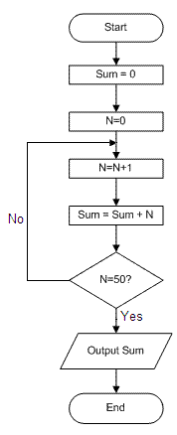

**Exercises**

1. Using Crocodile Clips draw and test a flowchart to find the largest of three numbers A, B, and C.
2. Using Crocodile Clips draw and test a flowchart to calculate N!
3. Using Crocodile Clips draw and test a flowchart to read a number N and print all its divisors.
4. Using Crocodile Clips draw and test a flowchart for computing the sum of the digits of any given number
5. Using Crocodile Clips draw and test a flowchart to find the sum of given N numbers.
6. Using Crocodile Clips draw and test a flowchart to compute the sum of squares of integers from 1 to 50
7. Using Crocodile Clips draw and test a flowchart to arrange the given data in an ascending order.